Enabling cli in vs code for propt
Open terminal
Then type ctrl+I and then give command example create a file and give
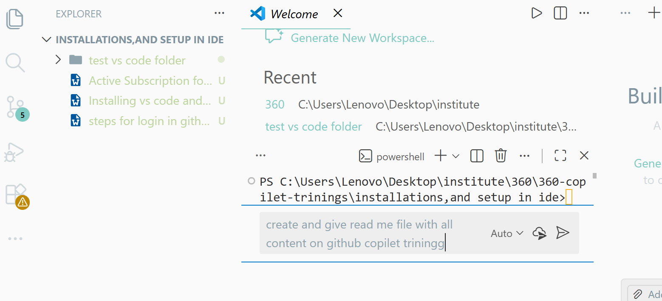
Then enable
